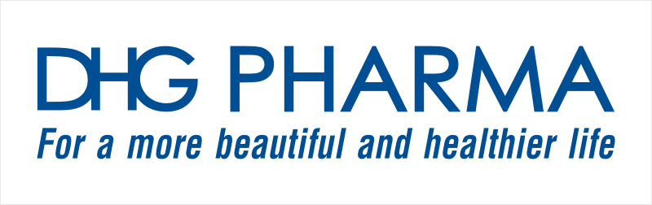 | THE SOCIALIST REPUBLIC OF VIETNAM  Independence – Freedom – Happiness
CONFIRMATION PAPER OR POWER OF ATTORNEY
ATTENDANCE AT THE ANNUAL GENERAL MEETING OF SHAREHOLDERS (“AGM”) 2021

Kind attention to: DHG Pharmaceutical JSC (“DHG Pharma”)

Name of shareholder: Shareholder’s code:……………
ID Card/ Passport/ Citizen Identification/ Enterprise Registration Certificate
No.:…..................………………….issued date:
The legal representative of shareholder being an organization:
Address:

Currently owns: ...................................................................................... shares of DHG Pharma.

I/We, hereby, confirm my/our attendance or authorization at the AGM 2021 of DHG Pharma:
1. Directly attending (Please mark X into this box)
Or:

2. Authorizing another person to attend (Please mark X into this box)
The Authorized Person:
ID Card/ Passport/ Citizen Identification No.:
Issued date:…………………at:
Address:

Or:

3. Authorizing the Board of Directors (“BOD”) of DHG Pharma (Please mark X into one of the following boxes to authorize to one of the members)
Ms. Dang Thi Thu Ha  Mr. Masashi Nakaura  Mr. Doan Dinh Duy Khuong  Mr. Do Le Hung  Ms. Nguyen Thi Viet Thanh | - BOD Chairwoman  - BOD member, General Director  - BOD member, Chief Operating Officer  - Independent Board Member  - Independent Board Member

The number of shares being authorized:

to attend the AGM 2021 of DHG Pharma and perform all rights and obligations at the AGM corresponding to the authorized shares. The Authorized Party has to act within the scope of authorization and may not delegate any authority to any third party except for being accepted by the Authorizer.
I/we am/are solely responsible for this authorization and undertake to strictly comply with applicable law and the Company’s Charter. This Power of attorney shall be effective from its signing date to the end of the AGM 2021.

...................., date ............................ 2022

THE AUTHORIZED PERSON SHAREHOLDER
Signature, full name, seal (if any) Signature, full name, seal (if any)

Note:
- Shareholder is advised to fax or send this confirmation paper/power of attorney to the Organizing board of the AGM of DHG Pharma before 4:00pm 14 Mar 2022 to the following address:
FINANCE DEPARTMENT - DHG PHARMACEUTICAL JOINT STOCK COMPANY
Address: 288 Bis Nguyen Van Cu, An Hoa Ward, Ninh Kieu Dist., Cantho City, Vietnam.
Tel: (0292) 3891433 (242) Fax: (0292) 3895209
Email: duongloan@dhgpharma.com.vn

- The authorized person is advised to carry the Power of attorney (original) when attending the Meeting. If the shareholder is an individual, the power of attorney must be signed by himself/herself. If the shareholder is an organization, the power of attorney must be stamped and signed by the legal representative of that organization. Foreign shareholder may apply Official Dispatch/ Letter of Authorization, but must fully meet the contents of the above power of attorney.
- Shareholder is only allowed to mark (X) in one of the three authorization confirmation boxes mentioned above to confirm your attendance or authorize another person or authorize the BOD member of the Company.

